NATIONAL ASSOCIATION OF PARLIAMENTARIANS®

213 South Main Street | Independence, Missouri 64050-3808
Phone: 816.833.3892 | Fax: 816.833.3893 | Toll Free: 888.627.2929 | E-mail hq@nap2.org
Website: http://www.parliamentarians.org Facebook: http://www.facebook.com/parliamentarians

Congratulations!

You have taken the first steps to organizing a new National Association of Parliamentarians® unit! Enclosed is material that you will need in applying for a charter from NAP.

Follow the enclosed instructions for organizing a new unit. When you have adopted your bylaws, fill in the “Request for Approval of New Unit Bylaws” form and send it along with a copy of your adopted bylaws and a copy of the application for unit charter to:

Steven Cook, Chairman
NAP Bylaws Committee
109 Bella Vita Drive
Clayton, NC 27527
sdcook@gmail.com

Remember to:
- Proceed carefully and thoughtfully;
- Refer to procedures outlined for “Organization of a Permanent Society” in Robert’s Rules of Order Newly Revised (12th edition);
- Study all enclosed material carefully;
- Follow all instructions;
- Consult with national, state or province officers, and/or your district director, if
necessary.

After you receive approval from the NAP Bylaws Committee, send a copy of your final bylaws to NAP Headquarters along with your application for unit charter and your members’ dues. A charter will be prepared and mailed to the newly elected president listed on the application.

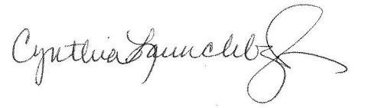
Please let us know if there are questions or if we can help in any way. Sincerely,

Cynthia Launchbaugh
Executive Director

cc: District Director
Association President

